Laycee Glass
OFM4 Task 3
Data Mining II
3/5/24
Western Governors University

OFM4 Performance Assessment, Task 3

Student Information
Student Name: Laycee Glass
ID Number: 001896026
Date: 3/5/24

Part I: Research Question

A1. Research Question
The question posed for this task was the following: What combinations of medications are most commonly prescribed together to patients?

A2. Goal of Analysis
The goal of this analysis was to identify and understand which medications are prescribed together at a frequent rate. This allows the hospitals to keep an adequate supply of these and have them readily available, reducing delays in treatment and improving patient care efficiency.

Part II: Market Basket Justification

B1. Market Basket
Market basket analysis is a technique that identifies associations and patterns in data. While it is commonly used in retail to uncover purchasing behaviors, in our case, it will be applied to prescription data to identify common medications patterns among patients.
This process relies on three metrics:
- support – frequency with which certain prescriptions appear together in patient records
- confidence – the likelihood that a patient prescribed one medication (antecedent, X) will also be prescribed another medication (consequent, Y), forming association rules such as “if X, then Y”
- lift – the strength of the association compared to what would be expected if the medications were prescribed independently (values greater than 1 indicated a meaningful relationship)

The expected outcomes of our analysis included identification of common prescription combinations (e.g. Patients prescribed Drug A are often prescribed Drug B) for optimization of medication supply (GeeksforGeeks, 2024).

B2. One Transaction Example
An example of a transaction from the provided dataset is shown below (including the code used to output):
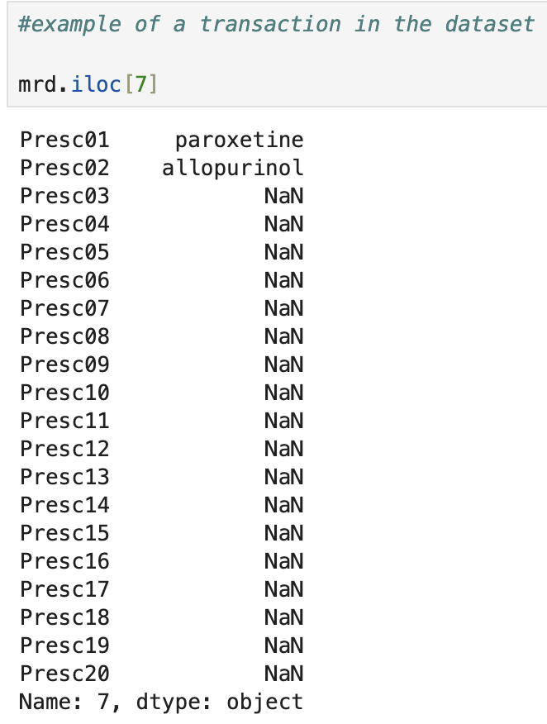

This transaction shows 2 medications were prescribed, Paroxetine and Allopurinol. Paroxetine is a selective serotonin-reuptake inhibitor (SSRI) that is used to treat depression and other mental illnesses by increasing the amount of serotonin in the brain. Allopurinol is a xanthine oxidase inhibitor that is used to treat gout and kidney stones by reducing the amount of uric acid in the blood (U.S. National Library of Medicine, n.d.).

B3. Assumption
For market basket analysis to be effective, certain assumptions must hold true. One assumption is that transactions are independent. In our case, each patient’s prescriptions are independent of those of other patients. This allows the data to become the primary focus, not the influence of one patient on another.
Another key assumption is presence of meaningful associations within the data. This means that certain prescriptions are frequently prescribed together, forming a consistent pattern. If these do not exist, market basket analysis cannot yield any useful results (GeeksforGeeks, 2024).

Part III: Data Preparation and Analysis

C1. Transformation
Before conducting our market basket analysis, I needed to clean and transform the data to be in a suitable format. Upon inspection of the data (seen below), I noticed every other row contained ‘NaN’ values (missing data). I removed these rows using the following code:
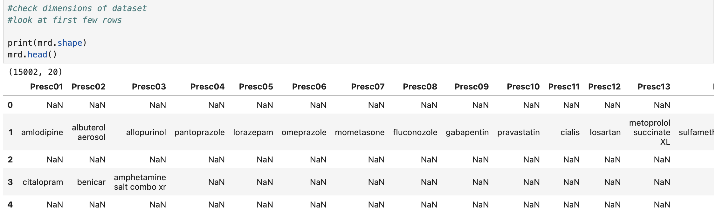
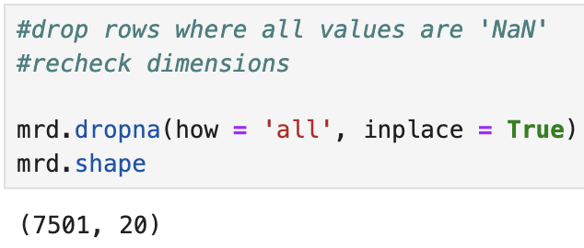

Market basket analysis requires data to be in a transactional format, meaning each row should represent a set of items purchased together. To achieve this, I compiled the dataset into a list of lists, where each sublist contained the prescriptions for a single patient. This prepared the data for encoding. This can be seen below:
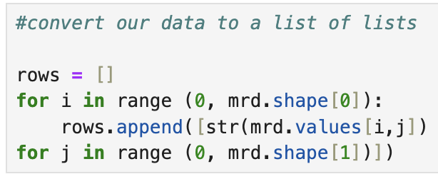

After this, TransactionEncoder was imported. The dataset was then fitted and transformed using such. This transformed data was then converted into a DataFrame where each prescription was represented as True or False. This ensure the data was structured correctly for frequent pattern mining using the Apriori algorithm. This is shown below:

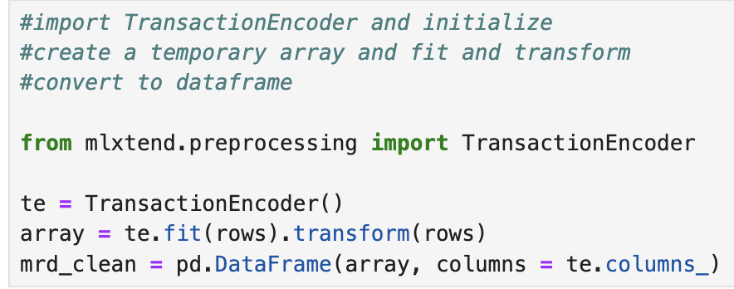

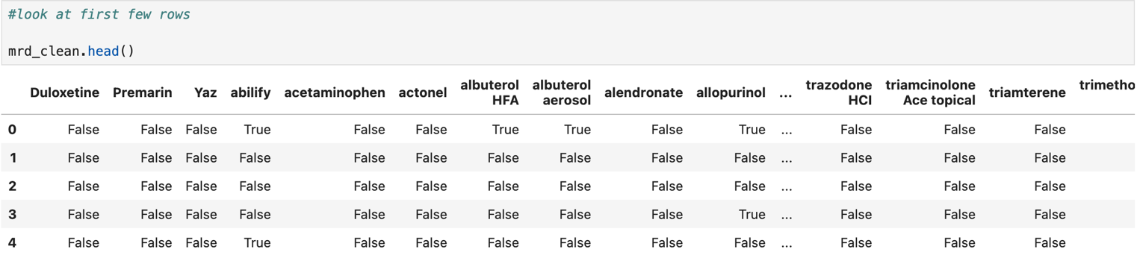
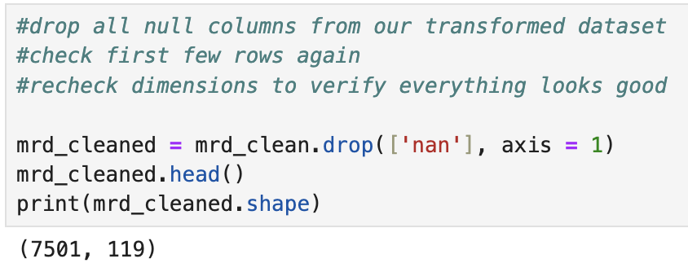
Once again inspecting the data, I observed some more null values that remained and could interfere with the analysis. To address this, I removed them using the following code:

Fully cleaned and formatted correctly, I exported the dataset to its own CSV file for submission. The code for this is shown below:

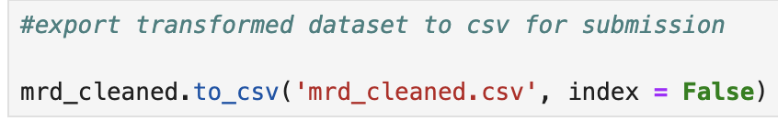

C2. Apriori Algorithm and Association Rules
Generating association rules was a two-step process. First, I applied the Apriori algorithm to identify frequent itemsets. In our case, this was any combination of medications appearing together in at least 3% of the transactions (min_support = 0.03). I chose a value of 0.03 to strike a balance between capturing stronger associations and excluding very rare combinations that may not be meaningful. This kept the focus on the meaningful and statistically significant associations. This Apriori function processed the transformed data and returned itemsets meeting the threshold. This code is shown below:
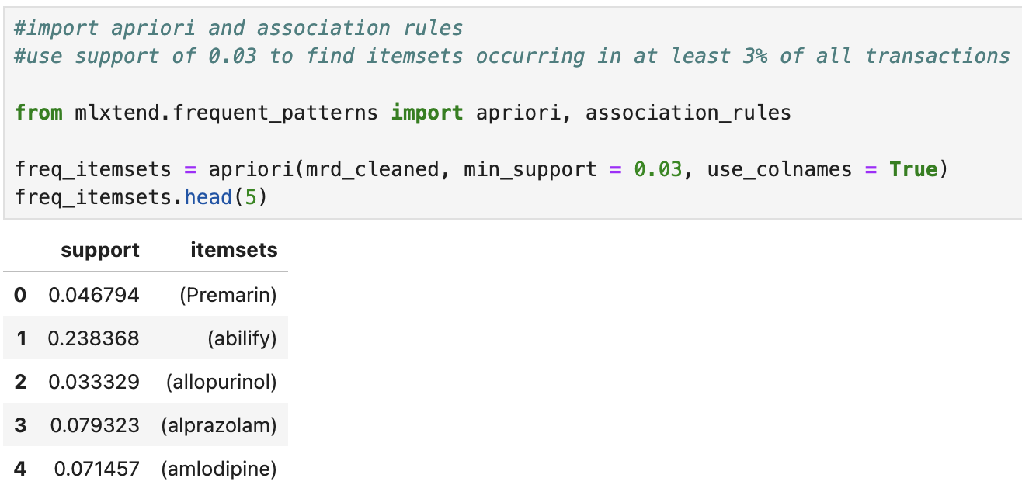

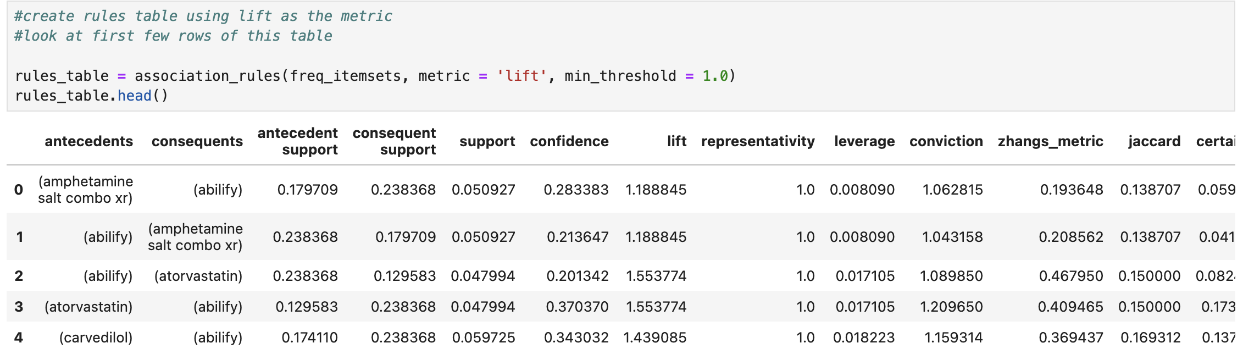
Once the frequent itemsets were identified, I used the association_rules function to extract rules based on the lift metric, setting a minimum threshold of 1.0. This helped refine the results by identifying the strongest associations, or those occurring more than expected by random chance. These were then put into their own rules table, shown below:

C3. Support, Lift, Confidence
The support, lift, and confidence values for the rules table are also shown above, but they are reproduced below for rubric purposes:

C4. Top 3 Rules
The top 3 rules generated by the Apriori algorithm are as follows:

Rule 1: {Carvedilol} -> {Lisinopril}
- Support: 3.92%
  - This combination of medications appears in 3.92% of patient prescriptions.
- Confidence: 22.51%
  - When a patient is prescribed Carvedilol, there is a 22.51% probability they will also receive Lisinopril.
- Lift: 2.29
  - Patients taking Carvedilol are 2.29 times more likely to be prescribed Lisinopril compared to random chance.

Rule 2: {Lisinopril} -> {Carvedilol}
- Support: 3.92%
  - As this combination is the inverse of rule 1, the frequency remains the same at 3.92%.
- Confidence: 39.89%
  - When a patient is prescribed Lisinopril, there is a 39.89% probability they will also receive Carvedilol.
- Lift: 2.29
  - Patients taking Lisinopril are 2.29 times more likely to be prescribed Carvedilol compared to random chance.

Rule 3: {Abilify} -> {Lisinopril}
- Support: 4.09%
  - This combination of medications appears in 4.09% of patient prescriptions.
- Confidence: 17.17%
  - When a patient is prescribed Abilify, there is a 17.17% probability they will also receive Lisinopril.
- Lift: 1.75
  - Patients taking Abilify are 1.75 times more likely to be prescribed Lisinopril compared to random chance.

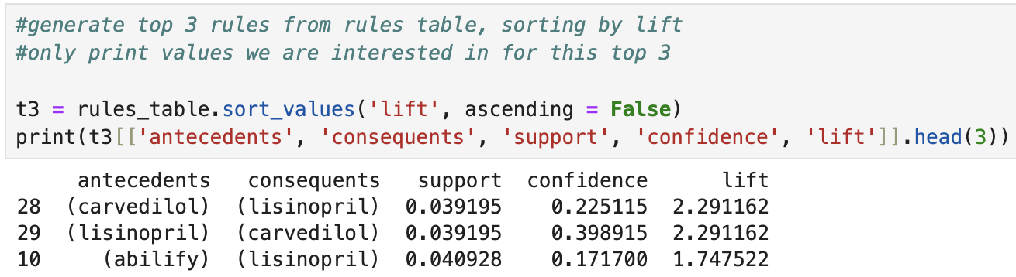
These can also be seen in the below screenshot of the code:

Part IV: Data Summary and Implications

D1. Support, Lift, Confidence Significance
When using the Apriori algorithm and association rules in data mining, three key metrics help evaluate the significance of associations between items:

- Support: Support measures the frequency of an itemset appearing in the dataset. A higher support value indicates that the itemset is more common. In our case, this means that certain combinations of prescriptions are more frequently prescribed together. As seen above, the support value of rule 1 was 3.92%. This is the rate at which the combination of Carvedilol and Lisinopril appears throughout all the transactions.
- Confidence: Confidence represents the conditional probability that a transaction containing one item (Drug A) also contains another item (Drug B). A higher confidence value suggests a strong likelihood that if Drug A is prescribed, Drug B is also prescribed. Above, rule 1 had a confidence value of 22.51%. So, Drug B (Lisinopril) is 22.51% more likely to be prescribed if the patient already has Drug A (Carvedilol).
- Lift: Lift evaluates the strength of an association by determining whether items occur together more often than expected by chance. A lift value greater than 1 indicates a meaningful relationship between prescriptions. Rule 1 had a lift value of 2.29, meaning when a patient is prescribed Drug A (Carvedilol), they are 2.29 times as likely to be prescribed Drug B (Lisinopril) as compared to being prescribed Drug B by random chance.

D2. Practical Significance
The rules identified by our analysis provide valuable insights for the hospital system. The strong association between Carvedilol and Lisinopril suggest that these medications are prescribed together. As a result, the hospital should make sure they are stocked together and readily available to prevent shortages and maintain current patient care.
While the association between Abilify and Lisinopril is not as strong, it still indicates a consistent pattern in prescriptions. This suggests Abilify should also be kept in proximity to Lisinopril to improve dispensing of medication.
By recognizing these patterns, hospitals can optimize inventory management, anticipate future medication needs, and enhance overall efficiency – ensuring they can fulfill current prescriptions while proactively preparing for future demand.

D3. Course of Action
Based on the results of our analysis, my biggest recommendation is to make sure Carvedilol and Lisinopril are stocked together and in sufficient quantities. This would prevent delays in treatment, ensuring patients get their medications in a timely manner. Since Abilify also has an association with Lisinopril, I would keep that in close proximity as well. This facilitates quick access as needed.
Additionally, integrating these findings into the hospital's electronic health record (EHR) system could provide significant value. For example, if a physician prescribes Carvedilol, the system could automatically suggest Lisinopril or Abilify based on the identified medication pairings. This would assist doctors in making data-driven prescribing decisions, ensuring that prescriptions align with common practices, improving patient outcomes and reducing prescribing errors.

Part V: Attachments

E. Panopto Recording
A recording has been submitted alongside this report demonstrating the functionality of the code.

F. Code Sources
D212 DataCamp courses
D212 Webinars

G. Text Sources
GeeksforGeeks. (2024, August 16). Market basket analysis in Data Mining. GeeksforGeeks. https://www.geeksforgeeks.org/market-basket-analysis-in-data-mining/
U.S. National Library of Medicine. (n.d.-a). Allopurinol: Medlineplus Drug Information. MedlinePlus. https://medlineplus.gov/druginfo/meds/a682673.html
U.S. National Library of Medicine. (n.d.). Paroxetine: Medlineplus drug information. MedlinePlus. https://medlineplus.gov/druginfo/meds/a698032.html#:~:text=Paroxetine%20is%20in%20a%20class,that%20helps%20maintain%20mental%20balance.

